- Cannot import the class from another py file?

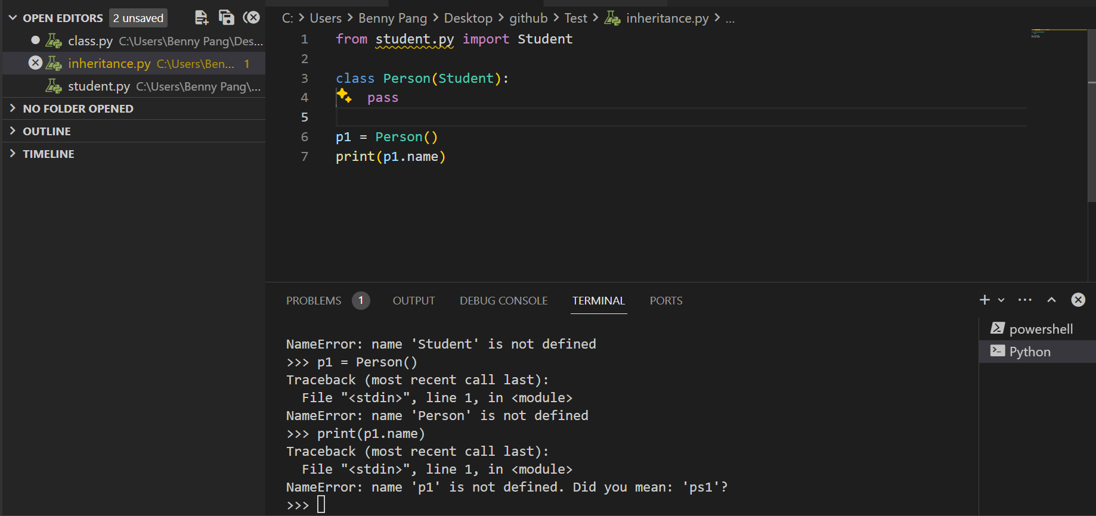

- Facing an error here

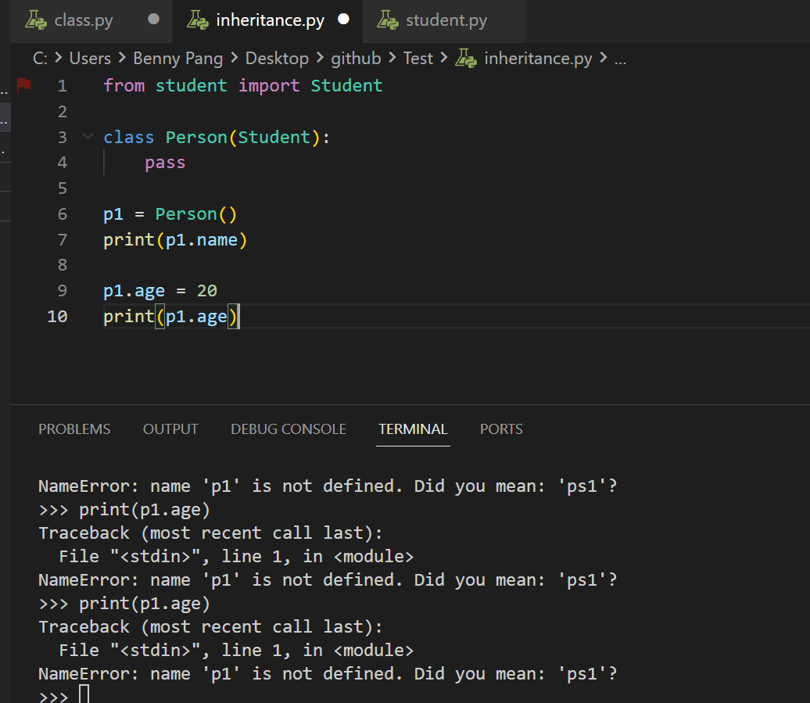

- Why the run code button cannot run the code in the terminal/ how to run the whole block of code

